Global meta-analysis of consumer-mediated nutrient cycling across latitudes

Alt: Consumer-mediated nutrient cycling across latitudes

Em G Lim¹ and Isabelle M Côté¹

Affiliations
¹Biological Sciences, Simon Fraser University, Vancouver, British Columbia, CAN

Corresponding author: Em Lim (ORCiD: 0000-0002-3586-2108), em.g.lim13@gmail.com

Abstract
Consumer-mediated nutrient cycling (CNC) refers to metabolic waste products of animals that can fertilize and bolster primary productivity. Despite the widespread assumption that CNC is less important in nutrient-rich temperate waters, empirical tests for global-scale patterns of CNC effects on primary producers are lacking. Here, we conducted a meta-analysis of published literature to assess the effects of animal-provisioned nutrients on primary productivity in marine ecosystems. We identified 41 suitable studies, from which we calculated effect sizes as response ratios of productivity of provisioned vs unprovisioned systems. We quantified and compared the effect sizes reflecting the growth benefit of CNC to primary producers between temperate and tropical regions, considering latitude, temperature, and external nutrients. Our results show no difference in the effect of CNC on primary productivity between temperate vs tropical regions, contradicting the prevailing ecological paradigm. This suggests that the effects of CNC on primary producers may be driven by smaller-scale processes that are not generalizable across broad regions.

Overview for intro:
- Bottom-up processes are super important. Different systems have different limiting nutrients. Needs of pp dictate how important provisioning is
- Animals contribute to bottom up processes. CND.
- CND super cool in the ocean? Nitrogen is limiting. External sources of nitrogen. Internal sources of nitrogen. Animals represent the largest pool of nutrients, so they dictate the rate of cycling.
- Theory states that provisioning is less important when nutrients are abundant, but there’s some exceptions (complementary timing, ideal ratio of delivery, bioavailable form). State the conventional wisdom assumption here.
- In this study…

Introduction
Although anthropogenic eutrophication has had some catastrophic effects across terrestrial and aquatic ecosystems (Smith et al., 1999), nutrient enrichment remains an important process in supporting primary productivity and thus ecosystem structure. Provisioning of nitrogen, phosphorus, and other limiting elements can produce dramatic increases in primary productivity (Elser et al., 2007). Nutrient provisioning is important only relative to the nutrient demands of the primary producer. For example, ___ is a limiting element for ____ (CITE) but does not appear to limit ____ growth (CITE). The impact of provisioning also depends on the availability of nutrients in the system; phosphorus enrichment famously causes algae blooms in lakes, while nitrogen fails to produce a similar bloom when added in isolation (Schindler, 1974). Finally, even the form of the supplied nutrients is important. In general, the addition of nitrogen and phosphorus in combination produces the largest increase in primary productivity across systems (Elser et al., 2007), although non-additive effects are common (Allgeier et al., 2011).

Although consumers are often assumed to mediate primary productivity through “top-down” effects, e.g. herbivory, they can also mediate “bottom-up” processes through metabolic nutrient release (Allgeier et al., 2017). Nutrient provisioning by consumers via excretion or egestion, henceforth termed consumer-mediated nutrient cycling (CNC), has been shown to substantially affect primary productivity and community functioning in aquatic (Atkinson et al., 2017; Vanni, 2002), terrestrial (McNaughton et al., 1988; Sitters et al., 2017), tropical (Meyer et al., 1983; Peterson and Heck, 2001) and some temperate (Bracken et al., 2007; Pfister et al., 2014) marine ecosystems. CNC refers both to the storage and cycling of nutrients through animal tissues, processes which are governed by stoichiometry (Elser and Urabe, 1999) and metabolic rates (REF). Scaling up from the individual to the population or community level can be challenging, but in general the amount of CND depends on the biomass and diversity of the total community of animals in a system (Allgeier et al., 2017).

In marine ecosystems nitrogen is the dominant limiting nutrient for primary producers (Ryther and Dunstan, 1971), which contrasts with terrestrial and freshwater ecosystems, which are co-limited by phosphorus and nitrogen (Elser et al., 2007). Specifically, the growth of many species of algae (Jackson, 1977), seagrasses (Hillman et al., 1989), and phytoplankton (Moore et al., 2013) is limited by the availability of inorganic nitrogen, both exogenous and endogenous. Exogenous nitrogen sources can profoundly affect marine primary productivity (Probyn and McQuaid, 1985; Smith et al., 1999). Coastal upwelling – the delivery to the surface of deep nutrient-rich waters via offshore winds– can be an important source of nitrogen that drives the productivity of temperate marine ecosystems (McPhee-Shaw et al., 2007). Two external terrestrial sources – natural weathering of rocks and agricultural run-off – also supply nutrients to nearshore marine ecosystems (CITE). However, upwelling, terrestrial input, and agricultural run-off supply nitrogen in the form of nitrates (NO₃⁻) which requires metabolic conversion by plants and algae before use (Probyn and McQuaid, 1985; Smith et al., 1999). In contrast, some animals, such as fishes and invertebrates, also contribute nitrogen (e.g. via excretion) in the form of ammonium (NH₄⁺), which is available for direct uptake and is thus preferred (Phillips and Hurd, 2004). Therefore, excretion by marine animals represents an important endogenous source of nutrients in marine ecosystems (Allgeier et al., 2017). Further, marine animals represent the largest pool of standing biomass, so their processes dictate the rate of internal nutrient cycling. Consequently, the total available nitrogen content in marine systems can dictate trophic energy transfer, and therefore total ecosystem biomass, mainly through bottom-up processes.

There is a widespread, although untested, assumption that the effect of CND should be largest in ecosystems with low external nutrient input, such as on coral reefs (REF). However, several lines of evidence do not support this assumption. CND has been shown to significantly bolster primary productivity in some areas with high external nutrient input, such as those frequently found in temperate latitudes. For example, Pfister et al. (2014) found that animal-derived ammonium contributed more to the overall nitrogen budget of a temperate rocky reef ecosystem than nitrates from upwelling. In temperate tidepools that are isolated from the ocean for extended periods of time, CND can prevent nutrient depletion and support continuous productivity (Bracken, 2004). Further, in high-nutrient upwelling systems, the delivery of nitrates may be mismatched with the timing of summer productivity (Jackson, 1977; McPhee-Shaw et al., 2007), necessitating alternative nutrient sources in the summer (Brzezinksi et al., 2013). Finally, even when nitrates are abundant, ammonium is more readily taken up by primary producers (Phillips and Hurd, 2004). Consumer-mediated nutrients might therefore be an overlooked source of nitrogen that drives bottom-up processes in temperate systems. Empirical tests for global-scale patterns of CNC effects on primary producers are currently lacking.

In this study, we assessed the effects of animal-provisioned nutrients on primary productivity in different marine ecosystems, and specifically test whether these effects are more marked in nutrient-poor environments. By conducting a systematic review and meta-analysis of published literature, we sought to quantify and compare the extent to which animals contribute more to the total nutrient availability in oligotrophic waters than external abiotic sources between temperate and tropical regions. Our results strengthen our understanding of consumers in mediating not just top-down processes, but also bottom-up processes on a global scale. Further, we hope this work will highlight the often-overlooked role of animals in marine nutrient dynamics.

Methods
We conducted a systematic review and meta-analysis of existing literature to investigate the effect of animal-provisioned nutrients on marine primary producers. We conducted two consecutive searches, first from 1900 - August 13, 2020, then from August 14, 2020 – January 3, 2022, using the same search strings and limits. The last day of each interval was the day the search was performed. We searched the Web of Science Core Collection (Web of Science) and Aquatic Sciences and Fisheries Abstracts (ProQuest) databased, and added two papers from our personal files. In Web of Science, we used the search string “nutrient AND excretion AND primary producer AND marine AND growth” with synonyms added for each word (See supplement). This search yielded 1,257 publications. We refined this list by only including articles and proceedings papers to filter out unreviewed articles, which narrowed the results to 1,164 publications. We then removed publications that were not included in the Web of Science categories: Marine Freshwater Biology, Environmental Engineering, Ecology, Oceanography, Zoology, Environmental Studies, Limnology, Multidisciplinary Sciences, Biology, Plant Sciences, Fisheries, or Biodiversity Conservation, to remove studies outside of our field, which were generally not relevant, resulting in 1,006 publications. We supplemented this list by conducting a search in the database of Aquatic Sciences and Fisheries Abstracts using the same search string. This second search resulted in 1,428 publications, which narrowed to 1,169 publications once we included only published literature. We excluded the subjects: freshwater, bacteria, aquaculture, lakes, rivers, cyanobacteria, biogeochemistry, and nitrogen fixation to further narrow the results to 784 publications. We merged these two searches and removed duplicates (using revtools::find_duplicates() in R), resulting in 1,429 publications.

Each record had to meet the following criteria to be included: 1) the study was conducted in the marine environment, 2) animals were the primary contributors of manipulated or observed nutrient levels, 3) the response of primary producers to this nutrient provisioning was measured in terms of growth, abundance, weight or biomass, and 4) the study reported all necessary information required to calculate an effect size of animal-provisioned nutrients on primary productivity. This resulted in 37 records (Fig. 1). We extracted meta-data from these publications (i.e., mean, standard deviation, and sample size for both the unprovisioned control and the provisioned treatment) to calculate effect sizes as log-transformed response ratios (see below). When studies included multiple treatment levels, we only compared control and maximum treatment levels. For time series data we considered growth achieved between the first and last measurements (see Table SX for full list of the types of growth data). When standard errors or confidence intervals were provided, we calculated standard deviations from these values. When data were only available in graph form, we used the program WebPlotDigitizer (https://automeris.io/WebPlotDigitizer/) to extract the means and standard deviations. As some studies presented multiple experiments, our dataset included 172 comparisons of growth of primary producers under provisioned and unprovisioned conditions.

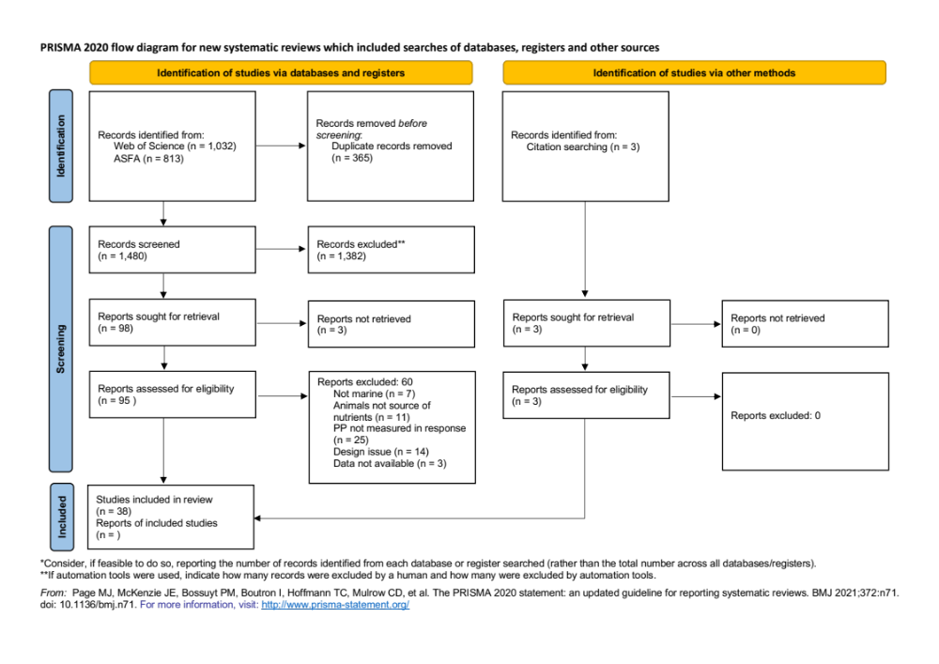
Figure 1: PRISMA diagram

We examined latitude, temperature, background nutrient concentration, the ‘openness’ of the experiment, and primary producer taxa as potential moderators of the effect of animal-mediated nutrient provisioning. We took the absolute latitude to reflect the distance of each study site from the equator (CITE). We estimated mean water temperature during the experiments from data reported in the publications, and extrapolated temperature from papers published in nearby regions when the raw data was not presented in the original text. We classified background nutrient levels as the total nitrogen present in the ambient or control treatment, which could include any combination of nitrate, nitrite and ammonium. When this data was not reported, we used background nutrient levels recorded in nearby studies. We standardized the continuous moderators (absolute latitude, temperature, and background nutrients) in the models to make the parameter estimates comparable. We scored each experiment for ‘openness’ on a scale of 1-5; (1) Field: natural experiment, (2) Field: primary producer manipulated, (3) Field: animal stocked, (4) Field: both primary producer and animals stocked, and (5) Lab: mesocosm experiment. Primary producers were grouped into either (1) macro?algae, (2) corals, (3) phytoplankton, or (4) vascular plants. We considered grouping primary producers into finer taxonomic levels (e.g., splitting fleshy and crustose algae, or seagrass and mangroves) but preliminary models with these finer groupings did not improve model fit, and we did not detect significant differences between finer groups within our chosen broader categories. We also collected data quantifying the level (i.e., concentration?) of provisioning by animals to primary producers, but this information was unavailable for most studies and inclusion did not improve model fit, so we did not consider this factor in final models.

Data analysis
We calculated effect sizes as log-transformed response ratios using the R package metafor::escalc, which computes effect size as the log of the treatment mean divided by the control mean. Effect sizes cannot be calculated for mean values less than or equal to zero (n = 9), so these were excluded. We constructed a full three-level mixed-effects model (metafor::rma.mv) including all moderators (absolute latitude, temperature, background nutrients, openness, and primary producer group) and a random effect of individual effect size nested within publication (random = ~ 1 | paper /individual_effect_size). As some studies contributed multiple effect sizes, this nested structure accounted for non-independence among our effect sizes (Viechtbauer, 2010). We used the restricted maximum likelihood estimator to estimate residual heterogeneity and used Cochran’s Q-test to test for significance for all models. We set test = “t” to use a t-distribution similar to the Knapp-Hartung method. We determined that absolute latitude, temperature, and background nutrients were correlated using a correlation matrix (metaphor::vif), so we then constructed three reduced models that each contained only one of the correlated moderators, in addition to openness and primary producer group, and competed them against a null model using Akaike’s Information Criterion.

Assumption testing
Meta-analyses can be vulnerable to p-value biases, so we calculated Rosenthal’s failsafe number (i.e., the number of non-significant studies we would have to include to overturn our results); the high failsafe-N = 13,962 relative to our sample size suggests that our results are robust to publication bias. As some papers contributed multiple observations, we examined whether papers that contributed 10% or more of the total number of observations (n = 3) had a substantial effect on the results. We reran each model repeatedly, removing one of these potentially influential studies at a time, and found no major differences in effect sizes or p-values. We therefore retained all three studies in the final analysis. Finally, we created funnel plots (Fig. S1) and visually inspected them for evidence of biases in the published effect sizes.
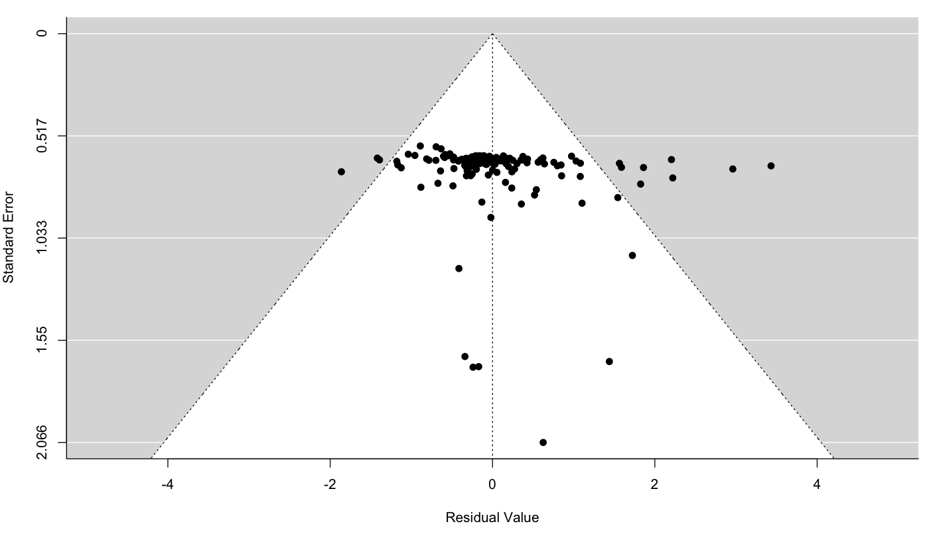
Fig. S1. Funnel plot for the model including background nutrients. What is residual value here? Effect size?? What’s your interpretation of this funnel plot?

Results
Overall, the effect of animal-provisioned nutrients on primary productivity was positive based on 37 studies, which contributed 172 individual effect sizes. Sample sizes were fairly evenly across the four categories of primary producers; each category represented 15-30% of the total sample. Unstocked field experiments (i.e, the most natural design) constituted the majority of experimental designs (43%), but all categories were well represented (8-43% of the total sample), with the exception of field experiments where both the consumer and producer were stocked (5%).

When we compared each of the models containing openness, primary producer group, and one of the correlated variables, i.e. absolute latitude, temperature, or background nutrients, against a null model, the model containing background nutrients had strongest support, but there was support for all three models with a correlated variable (2 < Δ𝑖 < 4), and little support for the null model (Δ𝑖 > 10, Table X). Therefore, we report results from all three models.

Background nutrients model
Overall, there was a positive effect of animal-provisioned nutrients on primary productivity (log-transformed response ratio ± SE; 0.59 ± 0.16, p = 0.0003), with producers growing nearly 4 times more, on average, under provisioned than control conditions. There was only weak evidence for a slightly positive effect of background nutrients on the effect of animal-provisioned nutrients on primary productivity (0.13 ± 0.07, p = 0.09; Fig. 3A). Including moderators was significantly better than a null model (F_{8,163} = 2.11, p = 0.04), although there was still a significant amount of residual heterogeneity unexplained by the model (QE₁₆₃ = 3083.73, p < 0.0001). Algae (0.59 ± 0.16; 389% increase) and corals (0.44 ± 0.20; 275%) showed the largest and consistently positive responses to animal-provisioned nutrients (Fig. 4). Phytoplankton (0.09 ± 0.24; 23%) and vascular plants (0.04 ± 0.20; 9.6%) showed significantly smaller and more uncertain responses to provisioning (Fig. 4). The responses of primary producers in unstocked field experiments (0.59 ± 0.16; 389%) were not significantly different than those in field experiments with stocked producers (0.36 ± 0.23; 229%) or mesocosms (0.68 ± 0.10; 479%). However, there was a larger effect of provisioning on primary productivity in field experiments with stocked consumers (1.01 ± 0.21; 1023%) or stocked consumers and producers (1.21 ± 0.31, 1621%; Fig. 5). The response ratios of all experimental designs, except field experiments with stocked producers, were consistently positive (Fig. 5).

Latitude and temperature models
We also found an overall positive effect of nutrient provisioning in the model including absolute latitude (0.59 ± 0.16, p = 0.0003). However, there was no evidence that the effect of nutrient provisioning varies with absolute latitude (0.01 ± 0.08, p = 0.85; Fig. 3B). There was weak support for this model over a null model (F_{8, 163} = 1.70, p = 0.10), and a significant amount of unexplained residual heterogeneity (QE₁₆₃ = 2974.54, p < 0.0001).
The model including temperature also showed a positive effect of nutrient provisioning overall (0.58 ± 0.16, p = 0.0004), but we found no evidence that the effect of provisioned nutrients varies with temperature (-0.06 ± 0.07, p = 0.45; Fig. 3C). This model was preferred over a null model (F_{8,163} = 1.78, p = 0.08), but there was still a significant amount of unexplained residual heterogeneity QE₁₆₃ = 3006.23, p < 0.0001).
For both the model with latitude and that with temperature, the differences between levels of the categorical moderators (i.e., experimental design and primary producer type) were roughly of the same in magnitude and significance as in the model that included background nutrients (Supplemental table X).

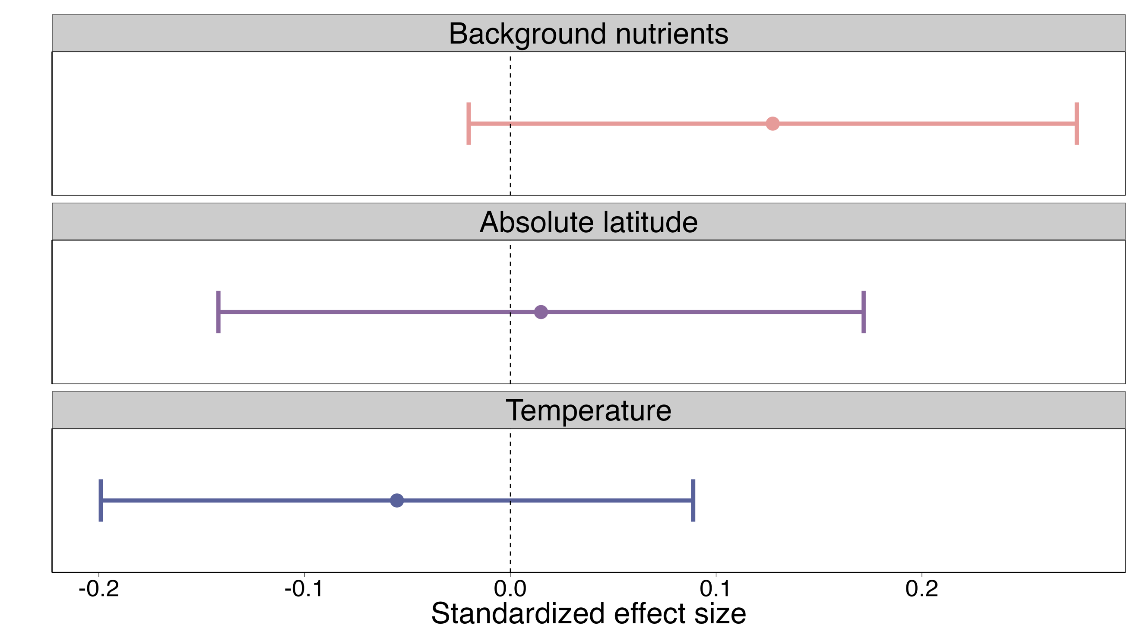
Fig. 3. Effect of A) background nutrients, B) absolute latitude, and C) temperature. Effect sizes are from three separate models each containing either background nutrients, absolute latitude, or temperature. In each model primary producer group and experimental design are also included as categorical moderators.
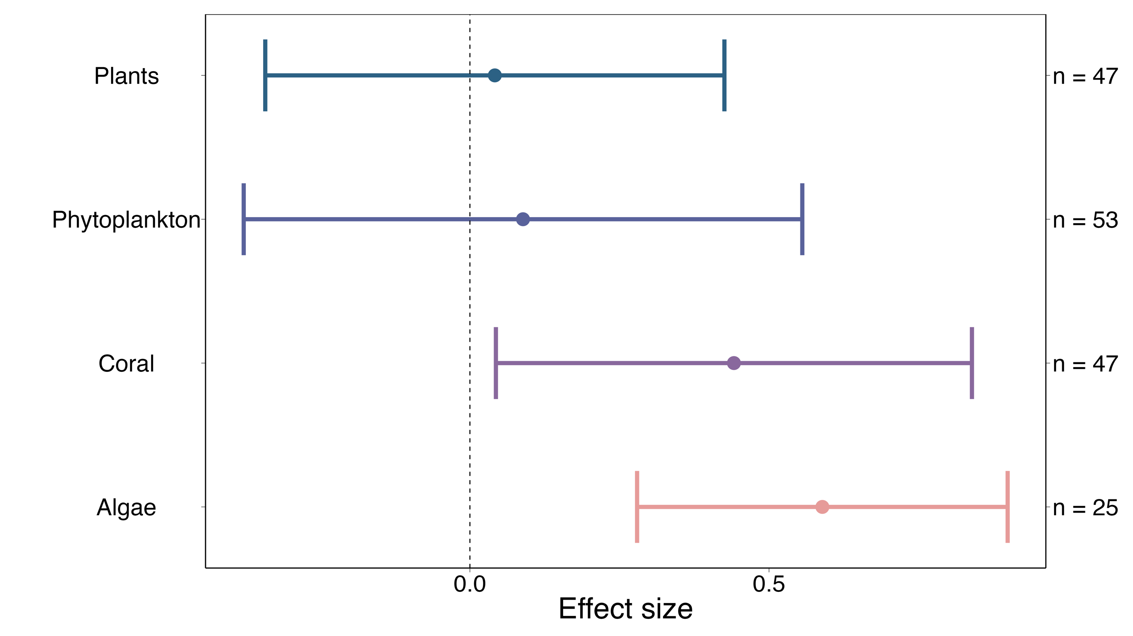
Fig. 4. Effect of animal-provisioned nutrients on different categories of primary producer. Plants include seagrasses and mangroves, phytoplankton include micro algae, coral includes measurements of both corals and coral endosymbionts, and algae includes fleshy and crustose algae. Effect sizes are log-transformed ratio of means surrounded by 95% confidence intervals derived from the three-level mixed effects model including background nutrients, primary producer, and experimental design as moderators. Sample sizes within each group are shown to the right of the effect sizes.

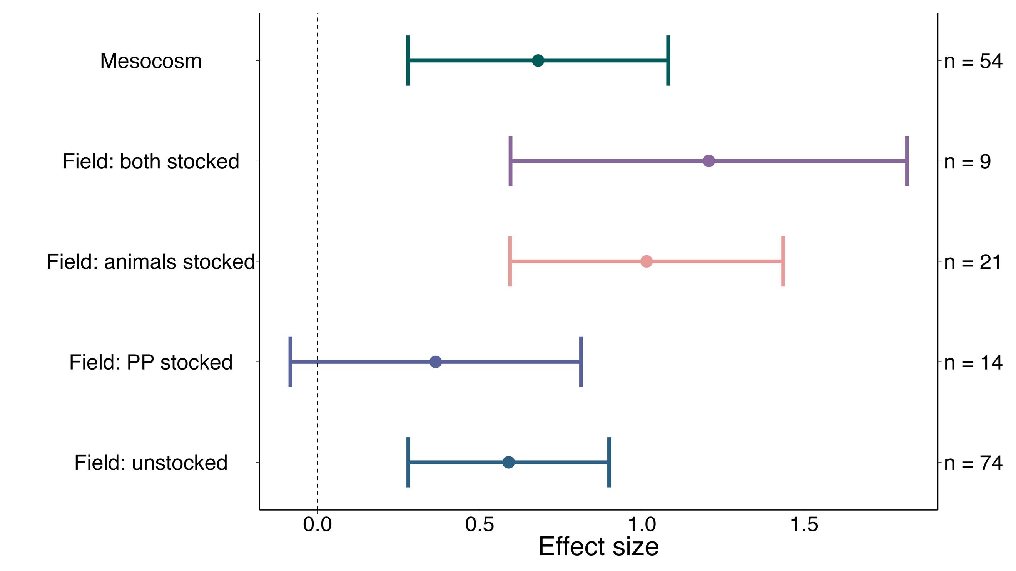
Fig. 5. Effect of animal-provisioned nutrients on different categories of experimental design. Field experiments were split based on whether the researchers set the density of the primary producer (PP stocked), consumer (animals stocked), both, or neither (unstocked). Effect sizes are log transformed ratio of means surrounded by 95% confidence intervals derived from the three-level mixed effects model including background nutrients, primary producer, and experimental design as moderators. Sample sizes within each group are shown to the right of the effect sizes.

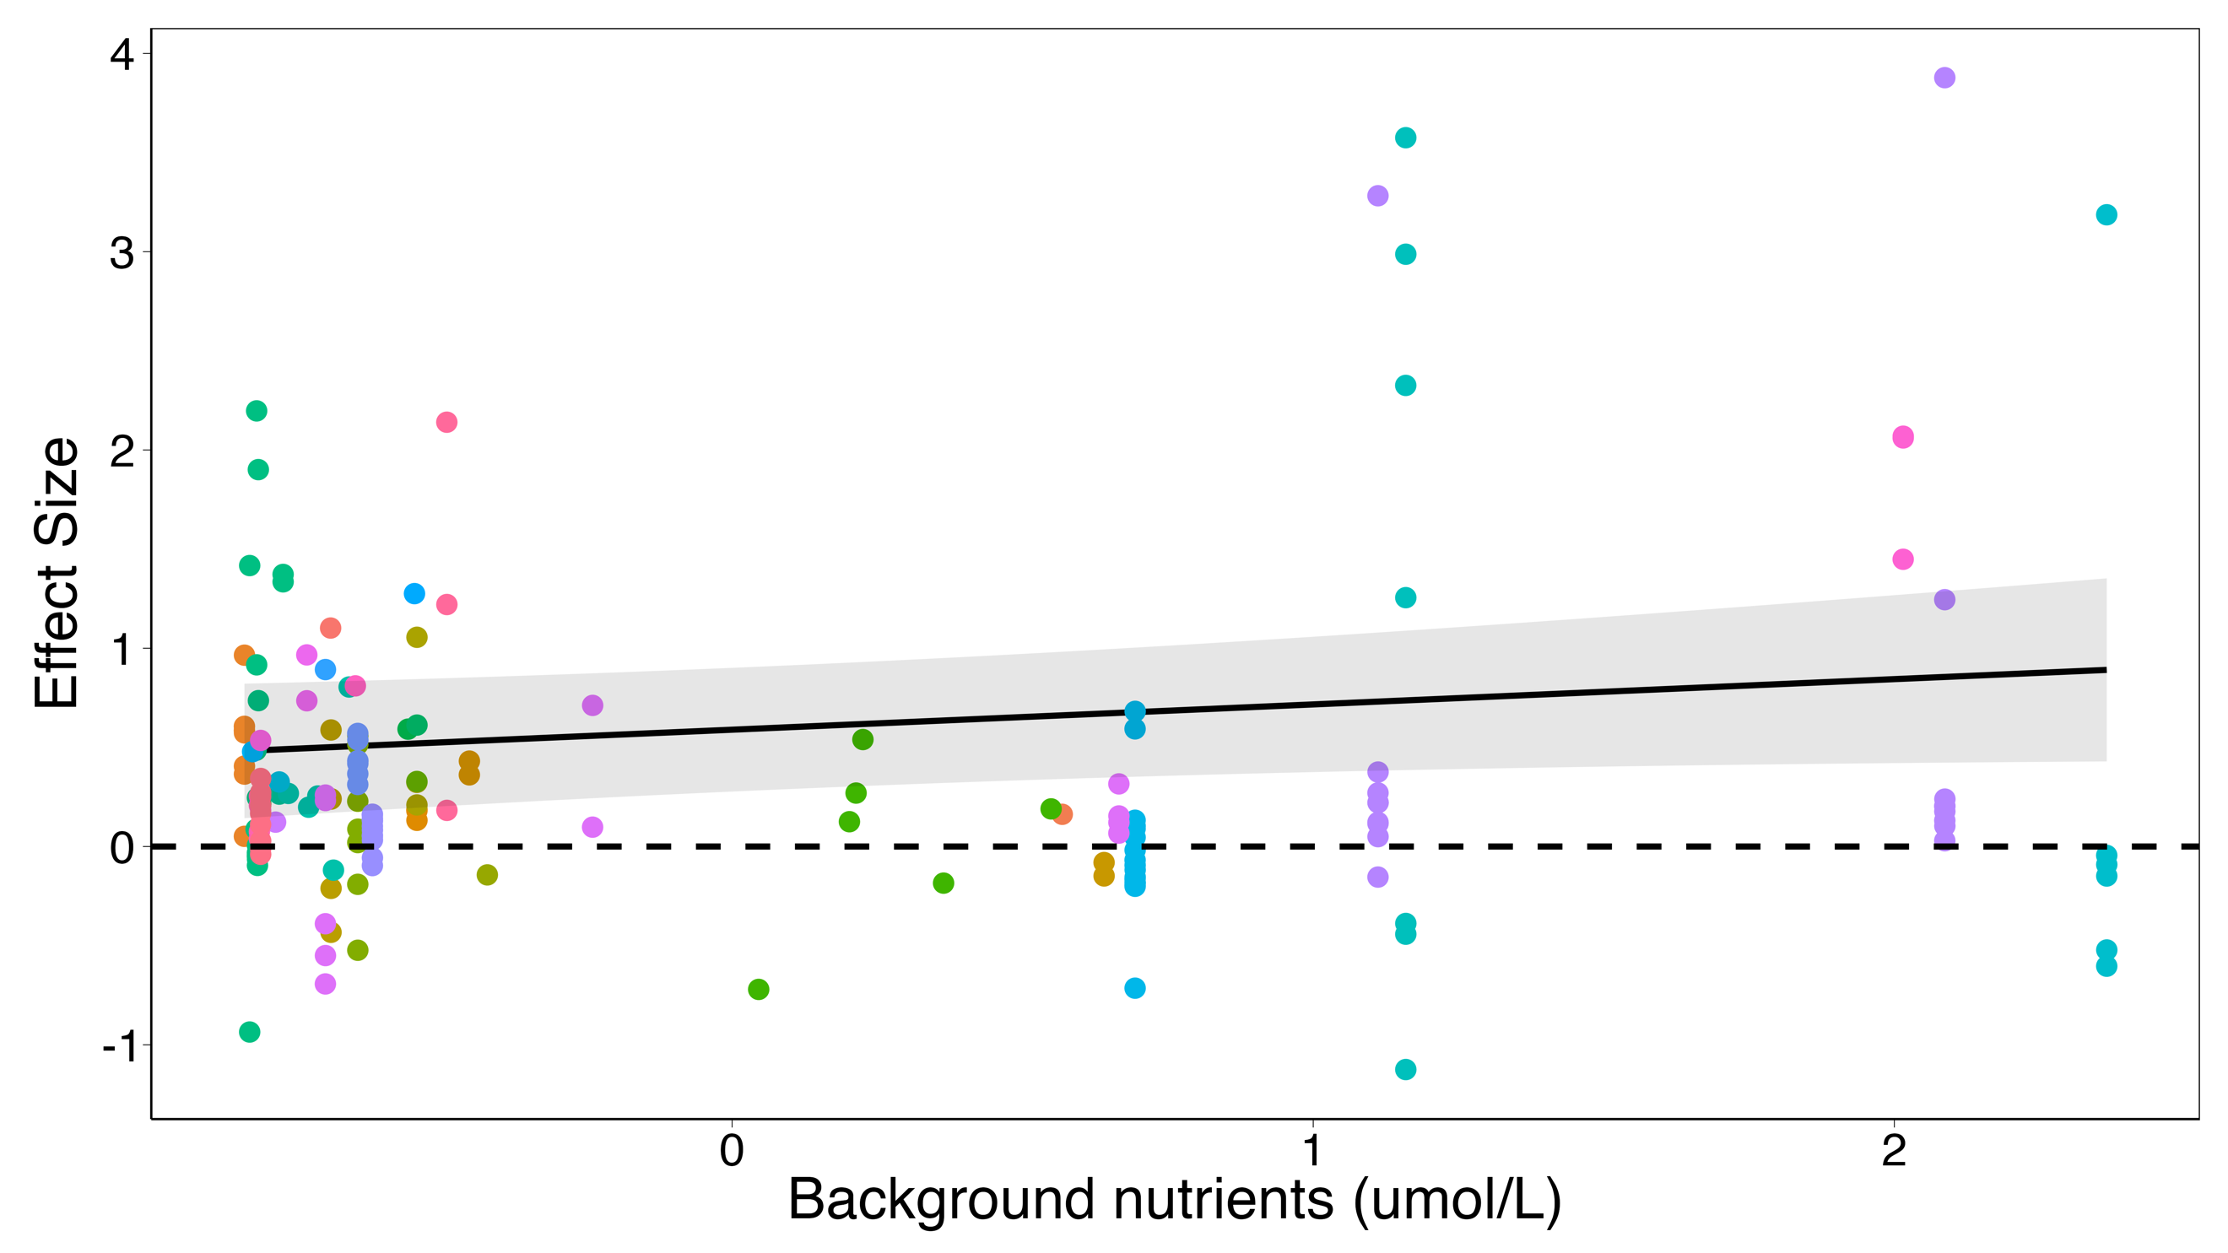
Fig. X. Effect of background nutrients on algae in unstocked field experiments. Dots represent effect sizes from studies. Background nutrients is standardized

SUPPLEMENT

Full search string
(ammon* OR nitrog* OR phosph* OR nutrient*) AND (excret* OR egest* OR mutual* OR symbio* OR subsid* OR consumer-mediat*) AND (coral* OR kelp* OR alga* OR macroalgae OR microalgae OR phytoplankton OR zooxanthell* OR primary prod* OR seagrass* OR sea grass* OR seaweed* OR mangrove*) AND (reef OR subtidal OR intertidal OR coast* OR marine OR benthic OR coral OR kelp) AND (grow* OR grew OR biomass OR abundance OR weight).

Table X: Model output for latitude model
 | estimate | SE | t-value | df | p-value
Intercept | 0.5944 | 0.1618 | 3.6732 | 163 | 0.0003
Lat_stand | 0.0149 | 0.0794 | 0.1878 | 163 | 0.8513
Natural2 | -0.2503 | 0.2340 | -1.0695 | 163 | 0.2864
Natural3 | 0.3396 | 0.2210 | 1.5363 | 163 | 0.1264
Natural4 | 0.5821 | 0.3154 | 1.8457 | 163 | 0.0668
Natural5 | 0.1611 | 0.2054 | 0.7840 | 163 | 0.4342
pp_groupCoral | -0.2116 | 0.2156 | -0.9812 | 163 | 0.3280
pp_groupPhytoplankton | -0.5231 | 0.2460 | -2.1265 | 163 | 0.0350
pp_groupPlants | -0.5194 | 0.2006 | -2.5889 | 163 | 0.0105

Table X. Model output for temperature model
 | estimate | SE | t-value | df | p-value
Intercept | 0.5816 | 0.1617 | 3.5976 | 163 | 0.0004
temp_stand | -0.0551 | 0.0729 | -0.7558 | 163 | 0.4508
Natural2 | -0.2326 | 0.2317 | -1.0038 | 163 | 0.3170
Natural3 | 0.3627 | 0.2163 | 1.6765 | 163 | 0.0956
Natural4 | 0.6027 | 0.3151 | 1.9130 | 163 | 0.0575
Natural5 | 0.1551 | 0.2038 | 0.7613 | 163 | 0.4476
pp_groupCoral | -0.1770 | 0.2111 | -0.8385 | 163 | 0.4030
pp_groupPhytoplankton | -0.5210 | 0.2417 | -2.1554 | 163 | 0.0326
pp_groupPlants | -0.5190 | 0.1976 | -2.6265 | 163 | 0.0094

References
Allgeier, J.E., Burkepile, D.E., Layman, C.A., 2017. Animal pee in the sea: consumer-mediated nutrient dynamics in the world’s changing oceans. Global Change Biology 23, 2166–2178. https://doi.org/10.1111/gcb.13625
Allgeier, J.E., Rosemond, A.D., Layman, C.A., 2011. The frequency and magnitude of non-additive responses to multiple nutrient enrichment. Journal of Applied Ecology 48, 96–101. https://doi.org/10.1111/j.1365-2664.2010.01894.x
Atkinson, C.L., Capps, K.A., Rugenski, A.T., Vanni, M.J., 2017. Consumer-driven nutrient dynamics in freshwater ecosystems: from individuals to ecosystems. Biological Reviews 92, 2003–2023. https://doi.org/10.1111/brv.12318
Bracken, M.E.S., 2004. Invertebrate-Mediated Nutrient Loading Increases Growth of an Intertidal Macroalga1. Journal of Phycology 40, 1032–1041. https://doi.org/10.1111/j.1529-8817.2004.03106.x
Bracken, M.E.S., Gonzalez-Dorantes, C.A., Stachowicz, J.J., 2007. Whole-community mutualism: Associated invertebrates facilitate a dominant habitat-forming seaweed. Ecology 88, 2211–2219. https://doi.org/10.1890/06-0881.1
Brzezinksi, M., Reed, D., Harrer, S., Rassweiler, A., Melack, J., Goodridge, B., Dugan, J., 2013. Multiple sources and forms of nitrogen sustain year-round kelp growth on the inner continental shelf of the Santa Barbara Channel. oceanog 26, 114–123. https://doi.org/10.5670/oceanog.2013.53
Burkepile, D.E., Hay, M.E., 2006. Herbivore Vs. Nutrient Control of Marine Primary Producers: Context-Dependent Effects. Ecology 87, 3128–3139. https://doi.org/10.1890/0012-9658(2006)87[3128:HVNCOM]2.0.CO;2
Elser, J.J., Bracken, M.E.S., Cleland, E.E., Gruner, D.S., Harpole, W.S., Hillebrand, H., Ngai, J.T., Seabloom, E.W., Shurin, J.B., Smith, J.E., 2007. Global analysis of nitrogen and phosphorus limitation of primary producers in freshwater, marine and terrestrial ecosystems. Ecology Letters 10, 1135–1142. https://doi.org/10.1111/j.1461-0248.2007.01113.x
Elser, J.J., Urabe, J., 1999. The Stoichiometry of Consumer-Driven Nutrient Recycling: Theory, Observations, and Consequences. Ecology 80, 735–751. https://doi.org/10.1890/0012-9658(1999)080[0735:TSOCDN]2.0.CO;2
Gruner, D.S., Smith, J.E., Seabloom, E.W., Sandin, S.A., Ngai, J.T., Hillebrand, H., Harpole, W.S., Elser, J.J., Cleland, E.E., Bracken, M.E.S., Borer, E.T., Bolker, B.M., 2008. A cross-system synthesis of consumer and nutrient resource control on producer biomass. Ecology Letters 11, 740–755. https://doi.org/10.1111/j.1461-0248.2008.01192.x
Hillman, K., Walker, D.I., Larkum, A.W.D., McComb, A.J., 1989. Productivity and nutrient limitation, in: Larkum, A.W.D., McComb, A.J., Shephard, S.A. (Eds.), Biology of Seagrasses : A Treatise on the Biology of Seagrasses with Special Reference to the Australian Region. Elsevier Science Pub., Amsterdam, The Netherlands, pp. 635–685.
Jackson, G.A., 1977. Nutrients and Production of Giant Kelp, Macrocystis pyrifera, Off Southern California. Limnology and Oceanography 22, 979–995.
McNaughton, S.J., Ruess, R.W., Seagle, S.W., 1988. Large mammals and process dynamics in African ecosystems. BioScience 38, 794–800. https://doi.org/10.2307/1310789
McPhee-Shaw, E.E., Siegel, D.A., Washburn, L., Brzezinski, M.A., Jones, J.L., Leydecker, A., Melack, J., 2007. Mechanisms for nutrient delivery to the inner shelf: Observations from the Santa Barbara Channel. Limnology and Oceanography 52, 1748–1766. https://doi.org/10.4319/lo.2007.52.5.1748
Meyer, J.L., Schultz, E.T., Helfman, G.S., 1983. Fish schools: An asset to corals. Science 220, 1047–1049. https://doi.org/10.1126/science.220.4601.1047
Moore, C.M., Mills, M.M., Arrigo, K.R., Berman-Frank, I., Bopp, L., Boyd, P.W., Galbraith, E.D., Geider, R.J., Guieu, C., Jaccard, S.L., Jickells, T.D., La Roche, J., Lenton, T.M., Mahowald, N.M., Marañón, E., Marinov, I., Moore, J.K., Nakatsuka, T., Oschlies, A., Saito, M.A., Thingstad, T.F., Tsuda, A., Ulloa, O., 2013. Processes and patterns of oceanic nutrient limitation. Nature Geoscience 6, 701–710. https://doi.org/10.1038/ngeo1765
Peterson, B., Heck, K., 2001. Positive interactions between suspension-feeding bivalves and seagrass-a facultative mutualism. Mar. Ecol. Prog. Ser. 213, 143–155. https://doi.org/10.3354/meps213143
Pfister, C.A., Altabet, M.A., Post, D., 2014. Animal regeneration and microbial retention of nitrogen along coastal rocky shores. Ecology 95, 2803–2814. https://doi.org/10.1890/13-1825.1
Phillips, J.C., Hurd, C.L., 2004. Kinetics of nitrate, ammonium, and urea uptake by four intertidal seaweeds from New Zealand. Journal of Phycology 40, 534–545. https://doi.org/10.1111/j.1529-8817.2004.03157.x
Probyn, T.A., McQuaid, C.D., 1985. In-situ measurements of nitrogenous nutrient uptake by kelp (Ecklonia maxima) and phytoplankton in a nitrate-rich upwelling environment. Mar. Biol. 88, 149–154. https://doi.org/10.1007/BF00397162
Ryther, J.H., Dunstan, W.M., 1971. Nitrogen, phosphorus, and eutrophication in the coastal marine environment. Science 171, 1008–1013. https://doi.org/10.1126/science.171.3975.1008
Schindler, D.W., 1974. Eutrophication and Recovery in Experimental Lakes: Implications for Lake Management. Science 184, 897–899. https://doi.org/10.1126/science.184.4139.897
Sitters, J., Bakker, E.S., Veldhuis, M.P., Veen, G.F., Olde Venterink, H., Vanni, M.J., 2017. The stoichiometry of nutrient release by terrestrial herbivores and its ecosystem consequences. Front. Earth Sci. 5. https://doi.org/10.3389/feart.2017.00032
Smith, V.H., Tilman, G.D., Nekola, J.C., 1999. Eutrophication: impacts of excess nutrient inputs on freshwater, marine, and terrestrial ecosystems. Environmental Pollution 100, 179–196. https://doi.org/10.1016/S0269-7491(99)00091-3
Vanni, M.J., 2002. Nutrient cycling by animals in freshwater ecosystems. Annual Review of Ecology and Systematics 33, 341–370. https://doi.org/10.1146/annurev.ecolsys.33.010802.150519
Viechtbauer, W., 2010. Conducting Meta-Analyses in R with the metafor Package. J. Stat. Soft. 36. https://doi.org/10.18637/jss.v036.i03

